Create a pig directory

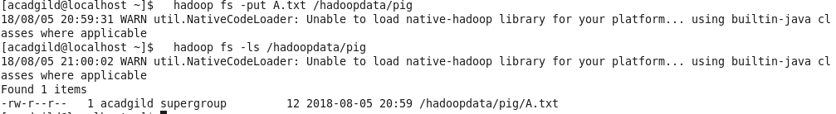

Load the files into it



Using cat see those files



Then dump those files and do the operations.